Module name:Age field validation
Test case ID:TC_01
Webpage URL:www.meesho.com

Scenario ID:1a

Scenario:Quantity with negative number
Test steps :

(1)open an application
(2)click on product add to cart.
(3)select a negative quantity no. for
product

Screenshots:

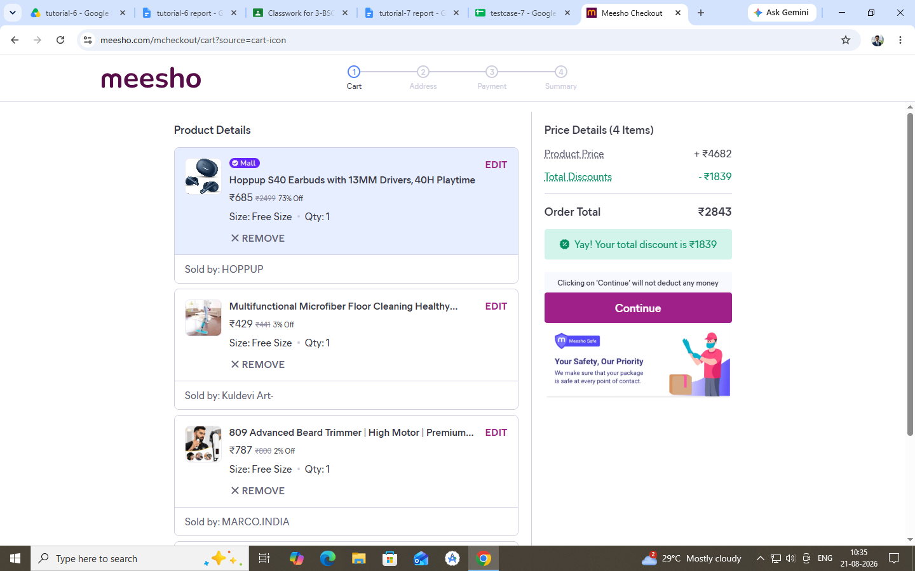

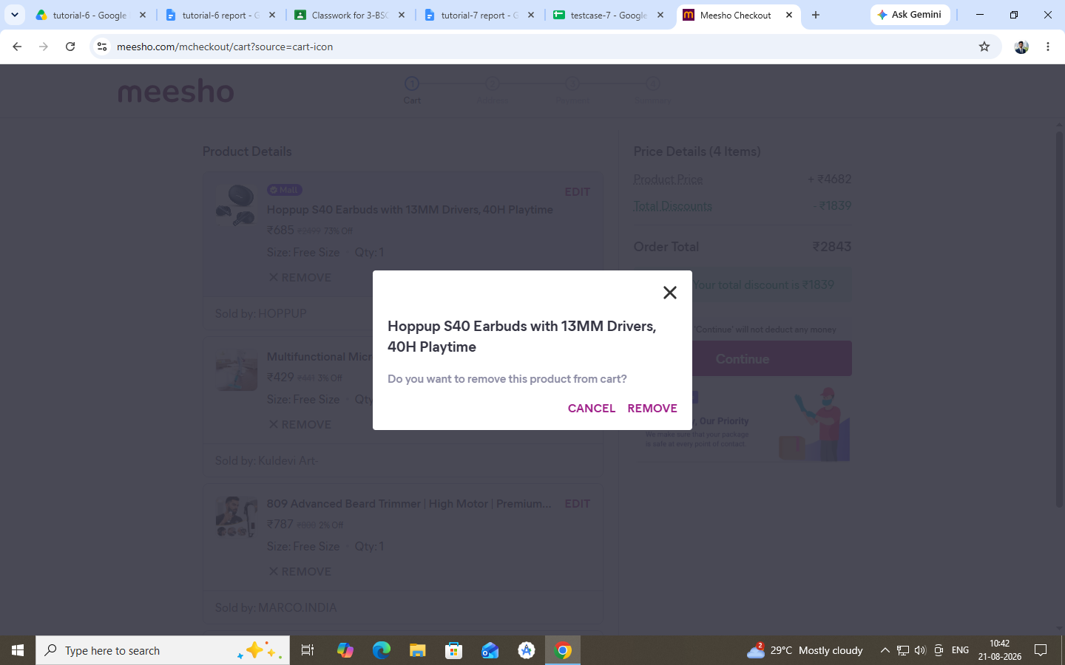

Scenario ID:1b

Scenario:Quantity with valid number
Test steps :

(1)open an application
(2)click on product add to cart.
(3)select a valid quantity no. for
product

Screenshots:

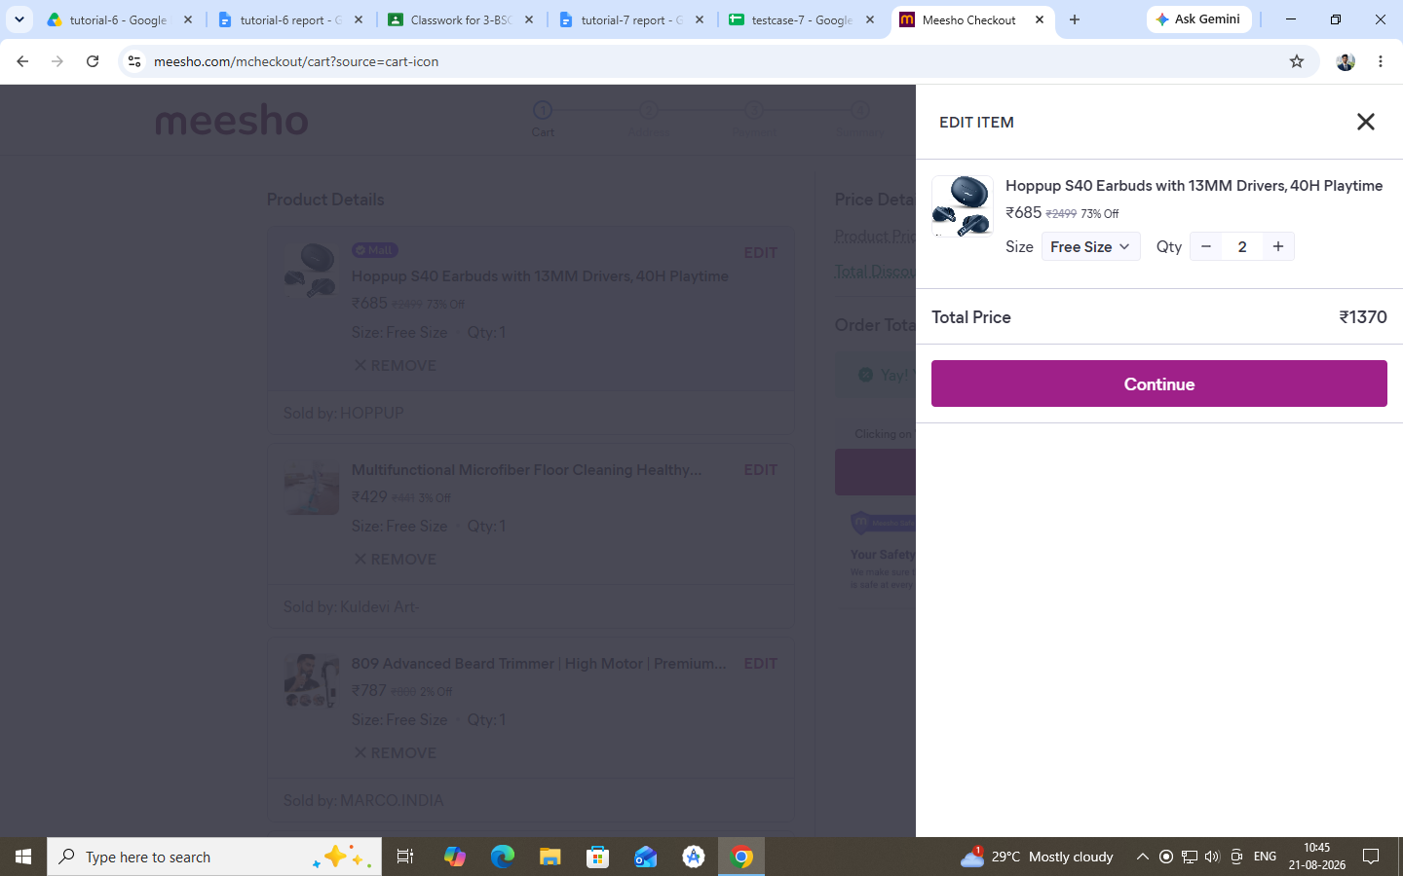

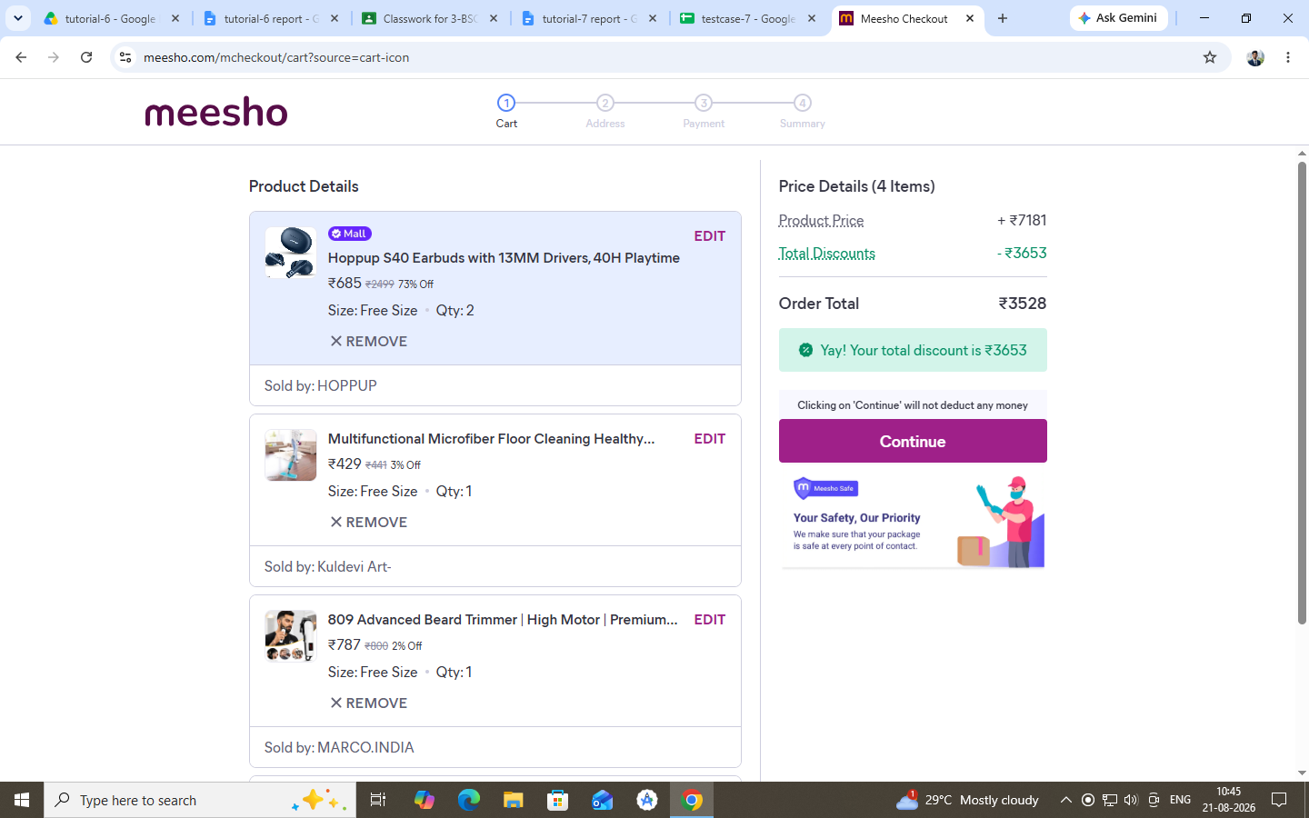

Scenario ID:1c

Scenario:Quantity with above the valid number
Test steps :

(1)open an application
(2)click on product add to cart.
(3)select a more quantity no then a
valid quantity for product

Screenshots:

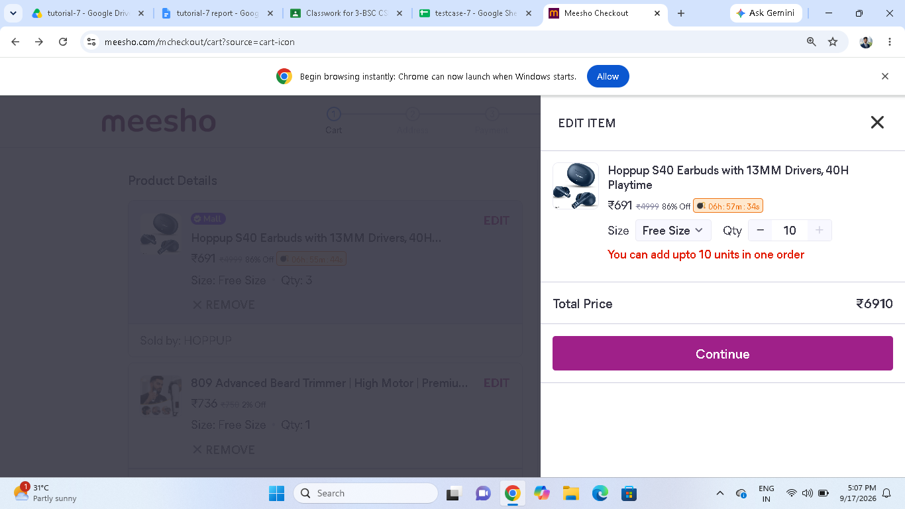

Scenario ID:1d

Scenario:Quantity with zero.
Test steps :

(1)open an application
(2)click on product add to cart.
(3)select zero quantity for product

Screenshots:

Scenario ID:1e

Scenario:Quantity with decimal number
Test steps :

(1) open an application
(2) click on product add to cart,
(3) enter a decimal quantity

Screenshots:

Scenario ID:2a

Scenario:Quantity with decimal number
Test steps :

(1) open an application
(2) click on product add to cart,
(3) enter a decimal quantity

Screenshots:

Scenario ID:2b

Scenario : Quantity with blank input
Test steps :

(1) open an application,
(2) click on product add to cart,
(3) leave the quantity field blank
and click submit.

Screenshot:

